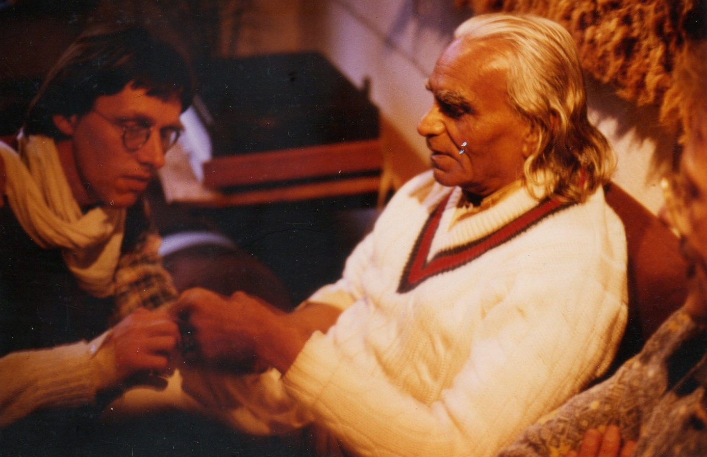

1985 Guruji during his visit to Amsterdam with John Floris

Look how the hand is made, how the fingers and hand are made and working……

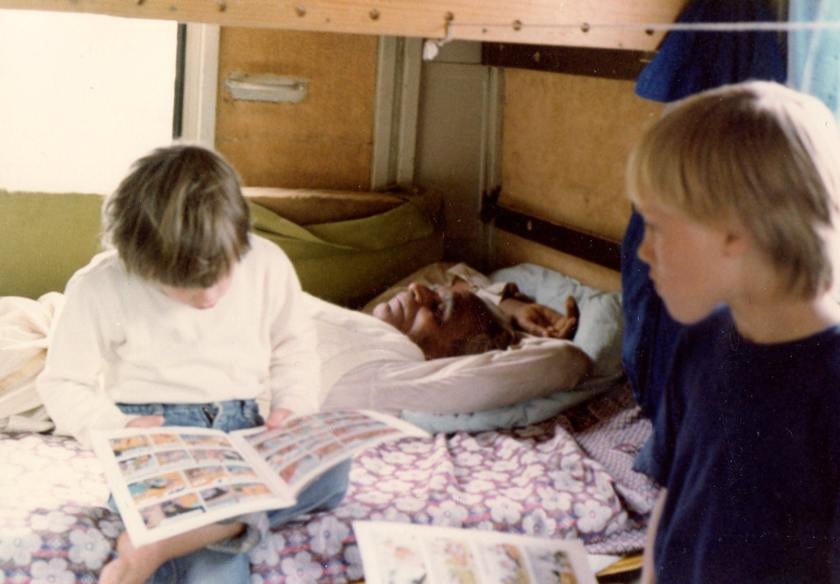

1985, France Guruji having a perfect savasana

Guruji was invited for 4 days teaching ( to teach) a group of about 200 people in Bitche, the North of France by another Yoga teacher, Mr. Mahesh.As Mr. Mahesh was of a complete different style of Yoga, a group of teachers from England, France, Italy, Switzerland and Holland came to assist in the classes.

After the teaching we often did some sightseeing in the surroundings. One of these days, we had to fetch Sylva Mehta from the train in Metz, a drive of about 3 hours. As Guruji was tired, we offered him a bed in our Citroen bus on the way back. After an hour of, we thought, sleep, he came up and said: “ I had a perfect savasana” and continued talking, laughing and enjoying like always.